Count Divisors
Platform: HackerEarth
Language: C
Module 5, Question 4

Problem Link
https://www.hackerearth.com/practice/basic-programming/input-output/basics-of-input-output/practice-problems/algorithm/count-divisors/

Problem Statement
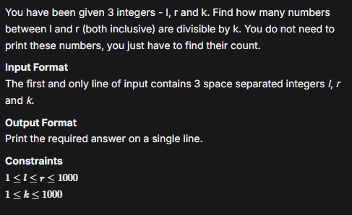

C Code
#include <stdio.h>

int main() {
long long l, r, k;
scanf("%lld %lld %lld", &l, &r, &k);

long long count = r / k - (l - 1) / k; // multiples of k up to r, minus those below l
printf("%lld\n", count);
return 0;
}

Screenshot of Successful Submission



